Shabbos Stories
For Purim 5784
Volume 15, Issue 30 14 Adar Sheni 5784/March 24, 2024
Printed L’illuy nishmas Nechama bas R’ Noach, a”h
For a free subscription, please forward your request to keren18@juno.com
Past emails can be found on the website – ShabbosStories.com
A Tale to Remember
The Fleishig Purim
Seudah and Siyum

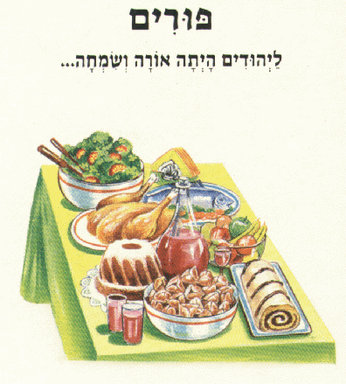
Torah Tavlin has a great story. A Bochur learning in Yeshivah, decided to do something special in honor of the Yarzeit of his grandfather, who had passed away on Purim, and he wanted to learn and make a Siyum in the Yeshivah on Purim night.
It was an admirable undertaking, as well as a Zechus for his grandfather. However, he had a problem. It was the night of Purim, when most of the Yeshivah’s students went out collecting Tzedakah in groups that were arranged weeks in advance.
How would he get a Minyan together in the Yeshivah? After brainstorming with some friends, he had an idea. He wrote a note and posted it on the Yeshivah bulletin board. It read: “I am trying to get a Minyan for a Siyum on Purim night. If you agree to learn for 90 minutes after Megilah Laining, I will make a Fleishig Seudah followed by a Siyum.”

A Local Jew Offers to Pay
the Cost for the Entire Seudah
A local fellow, Reb Mendy, who frequently visited the Yeshivah happened to see the notice and was intrigued by the concept. He approached the Bochur and told him what a great idea it was. He said that he was so taken by the concept that he offered to pay the cost for the entire Seudah.
The Bochur was very pleased with his offer, but he told Reb Mendy that since he didn’t expect a very large crowd to come, his offer was not necessary, and he thanked him anyway.
What happened next was unexpected. Perhaps their interest was piqued at the thought of learning at this unique time, or possibly bored by the thought of another Purim spent endlessly driving around, dancing in circles and getting dizzy, but close to eighty boys committed to the learning program!
When he saw how big the turnout was going to be, he realized that it was not in his means to pay for such an event, and he went back to speak with Reb Mendy, who had offered to sponsor the event, and asked if he was still interested in paying for the Seudah.

Dancing to Live Music
Reb Mendy said he would be honored to, and the Bochur happily took him up on his offer. On Purim night, eighty Bochrim learned with diligence for an hour and a half. They then had their Siyum and enjoyed a delicious, hot Seudah, and they then sang and danced to live music, which Reb Mendy also provided for them!
Most importantly, they all felt part of something special which enhanced their Simchas Purim. This feeling evidently endured, because the following year, when Reb Mendy arranged another learning Seder and Seudah after Megilah Laining, virtually the entire Yeshivah participated, which was about 180 Bochrim! A similar program was arranged for the Mesivta, and a few years later, other Yeshivos also joined in. Over time, there have been thousands of Yeshivah Bochrim who have been learning on Purim night!

Reprinted from the Purim 5779 email of Torah U’Tefilah compiled by Rabbi Yehuda Winzelberg.

A Purim Story
By Rabbi Sholom DovBer Avtzon

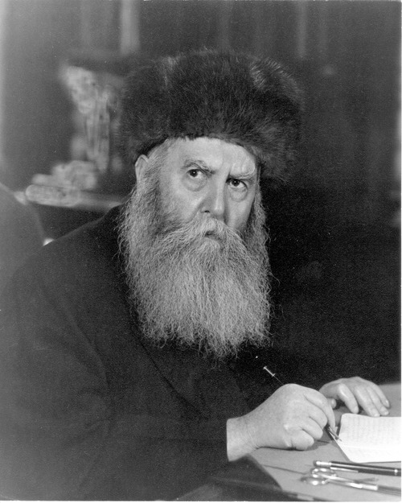
The Frierdiker Rebbe, zt”l

The Frierdiker Rebbe [of Lubavitch – Rabbi Yosef Yitzchak Schneersohn, zt”l,1880-1950] advised Reb Chatsha (Yechezkel) Himmelsthein to become a Rov in a certain town/city. Reb Chatsha known for his humility replied, “I am unworthy of becoming a Rov as there are certain halachos (laws) in Choshen Mishpat (monetary matters), that I am not a hundred percent clear in them.”
The Frierdiker responded by telling him the following story.
It was a Purim day and as in many towns and villages someone drank more wine or mashke than he should have and fell asleep on a bench. Some of the children saw him in his deep slumber and wanted to have some fun.
So they obtained the clothing of a gallach (a priest), (being it was on Purim, so it was a costume, when many people dress up) and put it on him. Sometime later, when this person woke up, he was still somewhat intoxicated, and saw that he was wearing the garb of a priest. Looking at himself, he said this is not possible, I am not a priest. I am a Jew.
However, being that his mind was still foggy he then said, “But I am wearing the garments of a priest, that means I must be a priest.” Unable to come to a conclusive clarity, he decided he would make a test to see if he is a gallach or not.

Unable to Read a Single Word
I will open up the book of gallachim and see; If I can read it, that means I am a priest, if I can’t read it that means I am not a priest. So, he opened one of the books and saw that he can't read a word, as it was written in a language (i.e. Latin) that is foreign from him. At that point he said I am definitely not a priest.
However, a moment later he rebuffed that proof, if I am not a priest, why am I wearing priestly garments?! The only ones who wear these vestments are gallachim (priests). He concluded, I am a priest, and most probably the majority of priests also cannot read it. After all, I am not a kayliche (crippled etc.) and if they can be a priest even if they can’t read this, I too can be a priest.
The Frierdiker Rebbe concluded, ‘A moral that is to be learned from this is, ‘Don't think that others are more endowed with wisdom than you. Everyone has their deficiencies; just those who succeed do not allow the deficiencies to hamper them on their path of success.
When I repeated this story to others, some of them informed me that they heard that the Frierdiker Rebbe’s message was much more than that, as well as there being a second message.

Learn from Those Who Have Accomplished Things
The Frierdiker Rebbe was telling him, when you are given a responsibility or task to accomplish, it is common for one’s “humility” to claim, I am incapable of accomplishing that. So, the message is, look at those who accomplished things, do you think initially they all had the talents to succeed? No, they didn’t, but they persevered and succeeded anyways. So too, even if it is true that you are missing clarity in certain halachos, with the time and perseverance, you will gain that knowledge.
The second point is; Your clothes or position may influence your behavior. However, at the same time one should realize, the garments on their own don’t make you into that person. The Frierdiker Rebbe wanted him to become a Rov, and by accepting that position does not fill in the void that he felt he was lacking in. He would have to toil to grow into that position.

Reprinted from the Purim 5779 email of Rabbi Avtzon’s Weekly Stories. Rabbi Avtzon is a veteran mechanech and the author of numerous books on the Rebbeim of Chabad and their chassidim. He is available to speak or farbreng in your community and can be reached at avtzonbooks@gmail.com
A Purim Miracle in Holland

Many years ago, in Holland, the crops were infested with worms, and people were concerned that there wouldn’t be anything to eat. The king of Holland declared a fast day. Everyone in his kingdom was obligated to pray and fast on a designated day.

The Question was Asked
To the Maaseh Rokeiach
The problem was, the day he chose was Purim. At that time the Maaseh Rokeiach lived in Holland. The Jewish community asked the Maaseh Rokeiach whether they should fast on Purim that year, to appease the king, or whether they should celebrate Purim like every year.
The Maaseh Rokeiach replied, “No one should fast. Make festive meals like every year. Tell the storeowners to distribute meat and fish and other foods for free. Afterwards I will pay back the stores…”
That Purim, the non-Jews were in their churches, praying and fasting, while lehavdil, the Jewish community was celebrating Purim like every year. The day after Purim, the problem was solved. The worms vanished and the crops were saved.
The king of Holland summoned the Maaseh Rokeiach to give an explanation. "Why didn’t the Jewish community obey my decree and fast?" The king was angry with the Jewish community, but he also respected them, especially the Maaseh Rokeiach. And since the worms vanished, he suspected that the Yidden may have acted correctly and caused the salvation.

Trying to be More Loyal to
Hashem’s Commandments
The Maaseh Rokeiach replied, “Everyone knows when punishment comes to the world, it is because of Bnei Yisrael. We understood that our sins stand at the root of the infestation and that the solution is teshuvah, to be more loyal to Hashem's commandments.
“The day you chose for a fast day was Purim, the day Hashem commands us to celebrate and rejoice. We know that the solution to the agriculture problem is to be loyal to Hashem’s decree. Therefore, we celebrated on Purim.”
The king accepted his explanation. (This story is recorded in Divrei Shmuel)

Reprinted from the Purim 5778 email of Torah Wellsprings: Collected Thoughts of Rabbi Elimelech Biderman.
Jews Don't Bow
By Azriel Hirsch

If you’d met me growing up in El Paso, Texas you wouldn’t have been able to tell I was Jewish. When I was six and my brother was 10, his gymnastics coach asked my parents if they would consider sending my brother to begin training to be an Olympic gymnast. My parents were in the middle of a divorce, and my brother’s future as an Olympic gymnast got buried under the mess of my parents’ lives. But I, unaware of this greater drama, did what all little brothers did. I followed my brother and joined gymnastics as well.
One day at gymnastics class, the instructor asked me to bow down for a gymnastics routine. I refused. “Aaron is something wrong?”

I Wouldn’t Budge.
“Please bow down like all the other boys and girls.”
Again, I remained adamant in silence. The gym coach had hit upon the only thing I knew from reform temple that as a Jew I was not allowed to do.
Struggling inside I finally spoke up, “Jews don’t bow down!”
I’d only started going to the reform Sunday school a year earlier but I remembered being told, as I sat in my Purim costume eating my first hamentashen, that Mordechai was a Jew and he didn’t bow down to Haman who turned himself into an idol. Jews don’t bow down.
I wouldn’t budge. Finally, my brother came over and explained to me that I wasn’t bowing to anybody, and that it was okay this time to bow.
At the end of 5th grade, I was one of the most popular kids in school. My friends and I listened to the music none of the other kids had yet heard of, and wore clothes before anybody had ever seen them, until one day all my good friends turned on me. I showed up at school and none of them would look at me. No one ever explained why. By the end of 6th grade some of these same friends who had fallen in with very violent people had even threatened to kill me. Later I would understand that G-d was pouring down his mercy on me and trying to rip me away from these superficial and troubled people, teaching me to look deeper into life.

Going to Church at St. Andrews
I told my parents that if they didn’t send me to private school I was going to drop out for fear of my life. My parents agreed and sent me to St. Andrew’s Episcopalian Parish School. (The Episcopalians are moderate Christian group somewhere between the ritualistic Catholics and non-ritualistic Protestants). It was a great move for me at the time. We wore uniforms and there were no popularity wars. The only downside was that every morning before school started I had to attend church. In the middle of the service everybody would line up for a wafer and wine before a cross, and say something like, "This represents the body of Jesus and the blood of Jesus.” One of the priests would insert the wafer in every child’s mouth. We negotiated that I would walk up with all the other kids but nobody was to ever put anything in my mouth.
Everything was fine until one day the headmaster left town for a week. When everybody kneeled down, the officiating priest noticed one child sitting contently in his seat. Breathless he caught up with me after church and announced, “You have to bow!”

“Jews Don’t Bow Down to Idols”
“I am a Jew. Jews don’t bow down to idols,” I answered back.
“If you don’t bow you can’t come to our school,” the priest shot back. By the end of the day, I had organized that the four other Jews in the school should also refuse to bow.
Our parents called up. The next morning the four of us sat, not bowing.
“Okay boys, just bow till Headmaster Simmons returns,” he tried again.
In unison we answered, “Jews don’t bow down.”
He was livid, but every day we would show up to their church and sit respectfully as everybody else bowed. Eventually they kicked me out. I left with one message clear for life: “Jews don’t bow down.”

Defiant
Some kids have more chutzpah than others. I had a lot, but G-d had arranged it that I directed the majority of my natural chutzpah at a society that I saw as insistent on having me bow down. Throughout the rest of high school and into college I found ever-subtler forms of how the non-Jewish culture I was living in was trying to get me to bow.
Whether it be through the guise of teen culture via high school prom dances, joining a football team, or a fraternity; or be it getting sucked into the pull of never-ending cycle of consumerism that tried to convince you that first you needed a car, and then a stereo to put in your car, and then a nicer car, etc. till you found yourself enslaved working to have the stuff that they claimed would make you somebody special.
My conclusion was to get as far away from Western culture as I could. I wasn’t quite sure where I was supposed to go. By 1993 I found myself in a land free of Western culture’s influence -- Moscow, Russia, after the collapse of the Soviet Union. I’d heard the Soviets were anti-Semitic so I didn’t tell anyone around that I was Jewish, and I never used my last name. Then one day I was sitting with the six friends I had made at the Russian university I was studying, I decided to confess.
“I want you all to know, I am Jewish.”
They all looked at me. “Oh really? So are we,” they all said nonchalantly.
I had traveled thousands of miles from my home, from everything I knew, to discover that being Jewish was something so powerful that even a fascist Soviet regime that wiped away all religion couldn’t keep seven Jewish souls who knew nothing about being Jewish from finding each other and bonding together. There was something in all of us that refused to bow.
Being Jewish somehow defied everything. I had no idea what it meant to be Jewish and I couldn’t ask them. For all they knew I could have been a rabbi. I just knew now for the first time in my life that my Judaism had to mean something.

Ripples of Mordechai's Strength
Six years later, a few weeks before Purim, I found myself sitting in Bnai Brak’s Ponevezh yeshiva. I could barely read the Talmud then, but I wanted to learn Tosfos, so every day after lunch, I would sit with a young yeshiva bochur for an hour who would go over the Tosfos again and again until I could repeat back what he said to me, even though I had no idea what it meant.
One day after my lesson I sat, and prepared for Purim when I read the words in Hebrew, "There was a Jewish man in Shushan the capitol whose name was Mordechai, son of Yair, son of Shim'I, son of Kish, a Benjaminite…" (Megilas Esther 2:5)

The Merit of the Tribe of Benjamin
I discovered that Mordechai was from the tribe of Benjamin. The verse told me that in order to discover the root of Mordechai’s strength to singly defy a world power. Benjamin was the only one of the 12 sons of Yaakov who did not bow down to Esav, the father of Western culture. This little fact rippled through one thousand years of history until it would show up in Mordechai, whose confidence in being a Jew would light up the waning faith of Jews in 127 countries, and overturn a government and genocide.
And it would continue to ripple for two thousand more years till it showed up in a little Jewish boy sitting in a reform temple in El Paso, Texas.

Reprinted from the 5775 Purim edition of Aish.com A version of this article originally appeared in Mishpacha Magazine.

